Exercise 1:
a.)
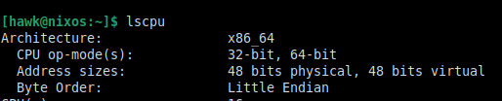
b.)
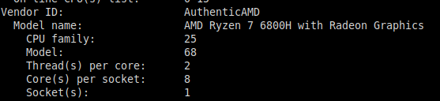
c.)
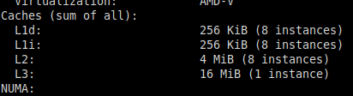
d.)
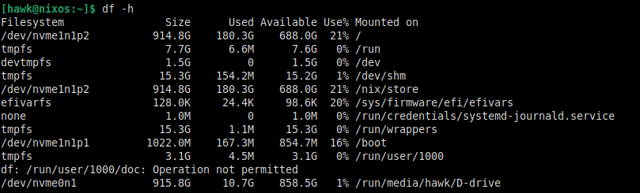
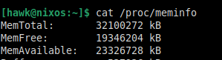

e.)
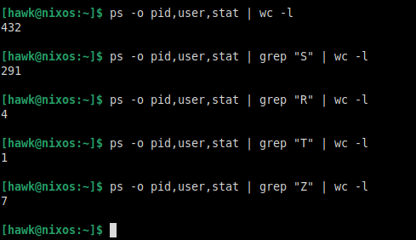
f.)
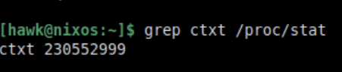

Exercise 2:
Mem1
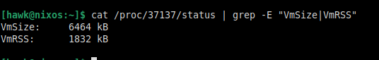
Mem2
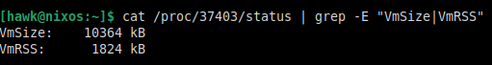
Mem3
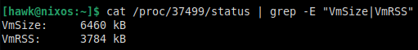

Mem4
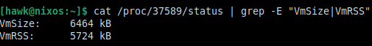
Ok, so
VmSize is the memory asked for by the process.
VmRSS is the memory it gets in RAM.
Mem1 and Mem2 ask for memory for 1M and 2M size array respectively so Mem2 gets double Mem1.
Mem3 and Mem4 ask for 1M so they should be similar to Mem1.
Comparing Mem3 and Mem4 they actually access the elements so they have more RAM usage with Mem4 accessing all of the array size and Mem3 accessing half of it so we see Mem4 being roughly double that of Mem3 after removing the base line used without accessing any of the array which can be seen from Mem 1 and Mem 2.

Exercise 3:
Ok first I looked for all processes that had subprocesses in their command using ps -ef. Then I looked at the top most one, got it’s process tree using pstree -p <pid> and verified which ones are it’s child processes and then used wc to count them.
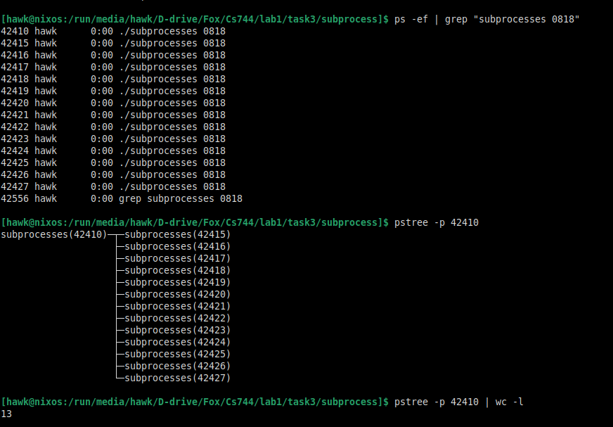
Exercise 4:
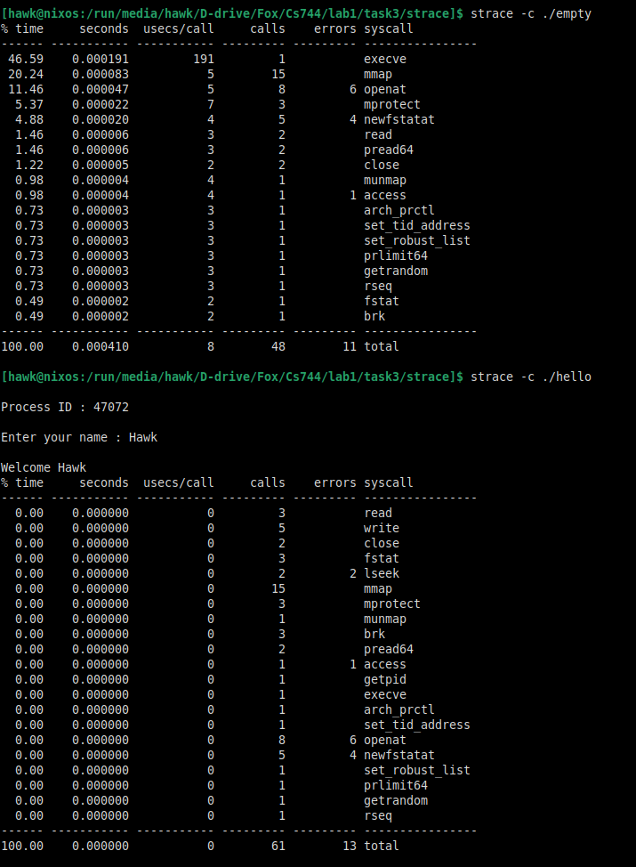

Common: execve mmap openat mprotect newfstatat read pread64 close munmap access arch_prctl set_tid_address set_robust_list prlimit64 getrandom rseq fstat brk
Unique to 2:
Write: displays something on the terminal
lseek: moves ouput offset
getpid: gets the process ID

Exercise 5:
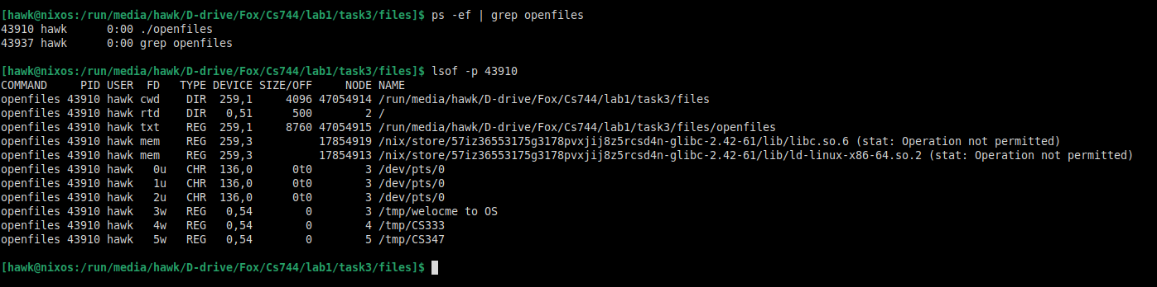
Got the Pid using ps -ef and then used lsof.

Exercise 6:
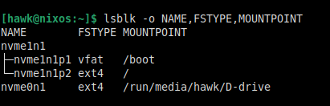
Block device name
File system type
Mount point

